**ENGN2605 Lab 08**

**Instructor: Prof. Benjamin Kimia**

**Name: Kuan-Min Lee**

**Brown ID: 140481859**

**Problem 1. Scene Reconstruction:**

The aim of this section of the experiment is to reconstruct the 3D view scene from a given pair images of two. The process will go as follow: first, we extract SIFT features from the two images and match them with their corresponding on the other image, and the coordinates of those features are also be extracted and treated as the coordinates in image planes. After the extraction of SIFT features, the essential matrix will later be determined and used for deriving the rotation and translation matrices. In the final step, the depth of the actual scene from camera will then be calculated and the image is projected onto a 3D image plane to show the depth of the actual scene. The following are the produced results:

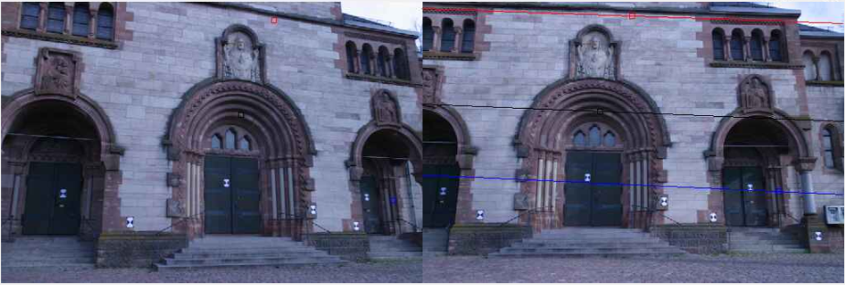

Figure 1: Epipolar Line of the Scenes

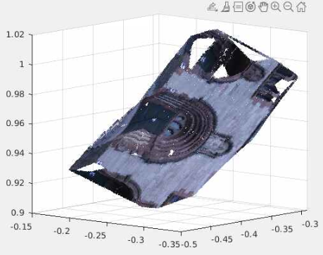

Figure 2: 3D Representation of the Scene

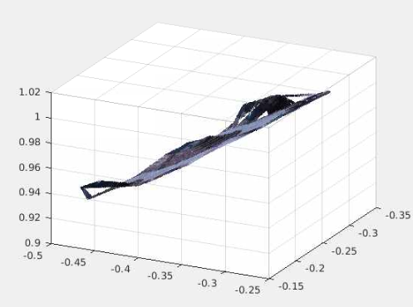

Figure 3: 3D Representation of the Scene

**Problem 2**

**Question 1:**

The dense feature is constructed by applying meshgrid and griddata function. These two functions are used to interpolate the data gap between each inlier. After the interpolation, the match pair are conducted with the bidirectional consistency check to make sure the left correspondences are the best match to each other. The reason behind conducting such interpolation is due to the sparse in the 3D image plane. The possible cause of making the feature sparse can be due to the five feature we randomly select to compute the essential matrix. The sparser the five points are between each other, the sparser the features are.

**Question 2:**

If the translation between the two camera is zero, the essential matrix can’t be computed since the essential contains two portion: rotation matrix and Tx matrix, which is represented as the cross product with translation vector, t.